Student Performance Prediction Using Linear Regression
Course: Machine Learning Lab
Student Name: Jadalla Hijazeen
Student ID: 20221501034
Section: 1
Instructor: Dr. Nadia Alrousan
Date: 2025-12-28

Table of Contents
- Abstract
- Introduction
- Problem Definition
- Dataset Description
- Data Preprocessing
- Exploratory Data Analysis (EDA)
- Model Implementation
- Model Evaluation
- Model Comparison
- Conclusion
- Limitations and Future Work
- References

Abstract
This project predicts students’ math scores using demographic and educational factors, along with reading and writing scores. The dataset contains 1000 records and 8 features. After data cleaning, one-hot encoding of categorical variables, and min-max scaling of selected numeric features, a Linear Regression model was trained and evaluated. The full-feature model achieved R² = 0.8948, MAE = 4.0025, and RMSE = 5.0811, outperforming a simplified model using only reading and writing scores (R² = 0.7022).

1. Introduction
Student academic performance prediction helps identify patterns that influence success and can support targeted interventions. This project focuses on predicting the math score of students using related academic scores and background variables.

2. Problem Definition
2.1 Objective
Predict the numeric value of math score based on the remaining dataset features.
2.2 Type of Machine Learning Task
This is a regression task because the target variable (math score) is a continuous numeric value.

3. Dataset Description
3.1 Dataset Size and Structure
From the program output:
- Shape: (1000, 8)
- Columns:
  - gender
  - race/ethnicity
  - parental level of education
  - lunch
  - test preparation course
  - math score
  - reading score
  - writing score
3.2 Data Types
- Numerical (int64): math score, reading score, writing score
- Categorical (object): gender, race/ethnicity, parental education, lunch, test preparation course
3.3 Summary Statistics (Key Values)
- Math score: mean ≈ 66.089, std ≈ 15.163, min 0, max 100
- Reading score: mean ≈ 69.169
- Writing score: mean ≈ 68.054

4. Data Preprocessing
4.1 Missing Values
The output shows 0 missing values in all columns. The code applies dropna(), which does not change the dataset due to no null values.
4.2 Duplicate Removal
drop_duplicates() is applied. The dataset remains 1000 rows, meaning duplicates were not present (or none removed).
4.3 Outlier Detection (IQR Method on math score)
The code computes:
- Q1 = 57
- Q3 = 77
- IQR = 20
- Lower whisker = 27
- Upper whisker = 107
Filtering rule applied:
- Keep rows where math score < 107
Since max math score is 100, this filtering removes no rows.
Note: the code removes only high outliers (above upper whisker), not low outliers (below lower whisker).
4.4 Feature Scaling
Min-Max Scaling is applied to:
- reading score
- writing score
This scales them into the range [0, 1].
4.5 Encoding Categorical Features
One-hot encoding (pd.get_dummies) is used for:
- gender
- race/ethnicity
- parental level of education
- lunch
- test preparation course
These are converted into binary indicator columns so the regression model can use them.

5. Exploratory Data Analysis (EDA)
5.1 Data Inspection
The code prints the first 10 rows, dataset shape, column list, info(), and describe() to confirm structure and distribution.
5.2 Visualization
Figure 1: Math score vs Reading score (Scatter Plot)
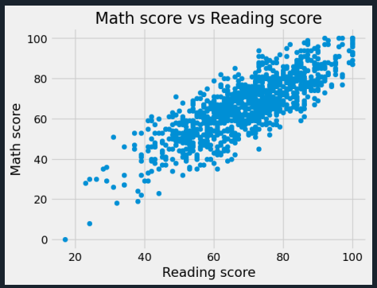
Interpretation: Reading score and math score show a positive relationship, indicating reading performance is a strong predictor of math performance.

6. Model Implementation
6.1 Model 1 (Full Feature Model)
- Model: Linear Regression
- Target: math score
- Features: all remaining columns after encoding/scaling
- Train/Test Split: 80% training, 20% testing (test_size=0.2, random_state=1)
Observation: Extremely large coefficients appear (≈ 10¹²–10¹⁴). This typically happens because dummy encoding includes all categories (no baseline removed), creating multicollinearity. The model can still predict well, but coefficients become difficult to interpret.

7. Model Evaluation
Since the project is regression, evaluation uses:
- MAE, MSE, RMSE, R²
7.1 Model 1 Results (All Features)
From the output:
- R²: 0.8948
- MAE: 4.0025
- MSE: 25.8172
- RMSE: 5.0811
Interpretation:
- Predictions are off by about 4 points on average (MAE).
- Typical error is about 5 points (RMSE).
- The model explains about 89.5% of variation in math scores (R²).
7.2 Residual Error Plot
Figure 2: Residual Errors (Train vs Test)
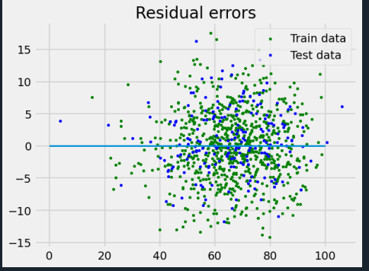
Residual plots help verify whether errors are randomly distributed around zero, which generally indicates a reasonable fit.

8. Model Comparison
8.1 Model 2 (Reading + Writing Only)
A second Linear Regression model is trained using only:
- reading score
- writing score
Results:
- R²: 0.7022
- MAE: 6.8969
- MSE: 73.0813
- RMSE: 8.5488
8.2 Comparison Table
Metric | Model 1 (All Features) | Model 2 (Reading + Writing)
MAE | 4.0025 | 6.8969
RMSE | 5.0811 | 8.5488
R² | 0.8948 | 0.7022
Conclusion: Model 1 is better because including demographic and education-related features improves prediction accuracy.

9. Conclusion
This project successfully predicts student math scores using Linear Regression. The dataset contains 1000 records with no missing values. Outlier filtering did not remove any records due to the computed upper whisker. The full-feature model achieved strong performance (R² = 0.8948) and significantly outperformed the simplified model using only reading and writing scores.

10. Limitations and Future Work
- Outlier filtering only checked the upper bound; low outliers were not removed.
- Very large coefficient values suggest multicollinearity due to including all dummy categories.
- Future improvements could include:
  - Dropping one dummy category per feature (baseline)
  - Trying regularized regression (Ridge/Lasso)
  - Adding more EDA plots (correlation heatmap, category-wise boxplots)

References
- StudentsPerformance.csv dataset (local file used in this project).
- Python Libraries: pandas, numpy, matplotlib, scikit-learn.

